
Vertex® Tax Links for Salesforce Commerce Cloud Configuration guide
Setup guide

Setup Guide

Copyright and legal notices

Copyright © 2020 Vertex Global Tax Solutions Ireland Holdings. All rights reserved.

This documentation may not be reproduced, displayed, distributed, modified, posted, republished, or transmitted in any form or by any means, without the prior written consent of Vertex Global Tax Solutions Ireland Holdings or its affiliates (collectively, “Vertex”), except as otherwise specified in a valid, current Vertex license agreement or allowed by law.

Disclaimers

The information contained in this documentation is designed to help users in regard to the subject matter covered. Some of it may be based upon interpretations of federal, state, foreign and other tax laws and regulations. Each entity is responsible for making its own determination of how such laws and regulations apply to its own circumstances and for evaluating the capabilities of, and all data and results generated by, any product that is described in this documentation. Vertex is not engaged in providing legal, tax or accounting advice or services and the information contained in this documentation or in any product cannot replace the advice of competent legal counsel. Further, the information in this documentation is subject to change without notice and is not warranted to be error‐free. If you find any errors, please report them to us in writing.

Trademarks and Service Marks

The trademarks, logos and service marks ("marks") displayed in this documentation are the property of Vertex or other third parties. Users are not permitted to use these marks without the prior written consent of Vertex or the third party that may own the mark.

Third Party Products

Copies of the licenses for some third‐party products included with a Vertex product may be found in or with the installation materials for that product.

Contents

Contents 3
Preface 4
About Vertex and our services 4
Contacting Vertex 5
About Vertex® Tax Links 5
About this guide 5
Compatibility 5
Chapter 1. Configure Salesforce Commerce Cloud 6
1. Configuration of the Vertex Business Manager extension 6
2. Vertex Connection Configuration 8
3. Check Lookup Tax Area and Tax Calculation services 11
4. Enabling communications Logs 13
5. Edit Custom Log Settings 14
Example of a Request and Response 16
Chapter 2. Custom Code Changes 17
Controllers 17
COShipping.js 17
COPlaceOrder.js 19
Address.js 20
COShippingMultiple.js 22
COBilling.js 24
Form definitions 25
shippingaddress.xml 25
billing.xml 25
billingaddress.xml 26
customeraddress.xml 26
Models 27
CartModel.js 27
ProfileModel.js 27
Scripts 28
CartUtil.ds 28
MergeQuantities.js 28
calculate.js 28
Resource.ds 30
Templates 30
JS 32
Resources 37

Preface

This preface contains the following information:

- About Vertex® and how to contact us about technical questions
- About Vertex® Tax Links
- About this guide
- Compatibility

About Vertex and our services

Vertex Inc. is the leading provider of corporate tax software and services for companies of all sizes, from small to medium‐sized businesses to global multinationals. Vertex provides solutions in every major line of tax including income, sales and consumer use, value added, and payroll. Vertex also offers tailored solutions for specific industries including retail, communications, hospitality, and leasing.

Vertex has offices in Berwyn, Pennsylvania; Sarasota, Florida; Naperville, Illinois; London, United Kingdom; and São Paulo, Brazil. For office addresses and telephone numbers, go to http://www.vertexinc.com/contact.

Contacting Vertex

Vertex provides the following services:

D
For... | Go to...
Technical questions about your products | Vertex Product Support  Phone: 800.281.1900 (Monday through Friday, 8:15 A.M. to 8:00 P.M. United States Eastern Time)  Web: https://my.vertexinc.com/
Documentation, downloads, forums, service requests, and up‐to‐ the‐minute information about tax rates, tax rules, and jurisdictions | The myVertex customer portal  Web: https://my.vertexinc.com/
Questions about your licensing agreement, license renewal, invoicing arrangements, or obtaining license files for your products | Vertex Account Services  Phone: 800.355.3500 or 610.640.4200  Web: www.vertexinc.com/contact
Regional training classes, web‐based training classes, or on‐ site training at your facility | Vertex Training  Phone: 877.455.2645 (Monday through Friday, 8:15 A.M. to 8:00 P.M. United States Eastern Time) option #2  Web: www.vertexinc.com/Support/training

About Vertex® Tax Links

Vertex® Tax Links for Salesforce Commerce Cloud you to integrate with Vertex® O Series® for tax calculation and address verification.

About this guide

The Setup Guide provides the following information:

- Configuration of Salesforce Commerce Cloud Connector
- Custom Code Changes in Salesforce Commerce Cloud

Compatibility

The cartridge is designed for Salesforce Commerce Cloud API version 19.10 (Compatibility Mode: 19.10).

Chapter 1. Configure Salesforce Commerce Cloud
You must configure the Salesforce Commerce Cloud connection for each web site, web store, and store view. You can select the store view on the top left of the Configuration section.

The configuration requires the following Vertex Tax Link settings, which you can get from Vertex O
Series:

- Vertex Calculation API URL
- Vertex Address Validation API URL
- Vertex trusted ID
- Company code
- Location code

Use the following steps to configure the connection in Salesforce Commerce Cloud

1. Configuration of the Vertex Business Manager extension

- Provide permission for Admin user to manage Cartridge preferences
  - Click on arrow by Administration Tab on top hand navigation
  - Click on Roles & Permissions under Organization section
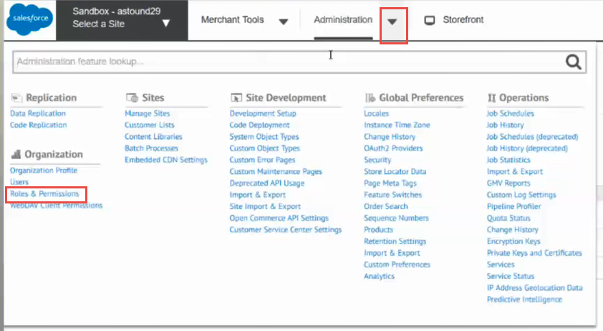

  - Click on Administrator link
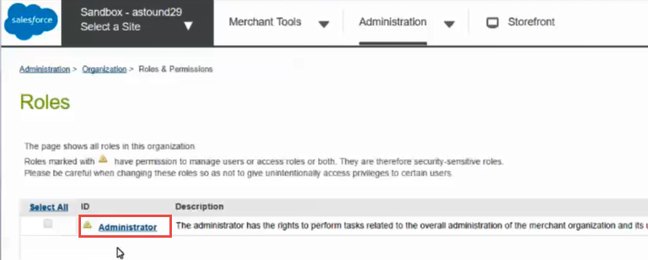
  - Click on Business Manager Modules tab on Administrator role page
  - Select Context pop up window will appear
  - Select site you want to allow Admin to be able to edit/change the cartridge in
  - Click Apply button
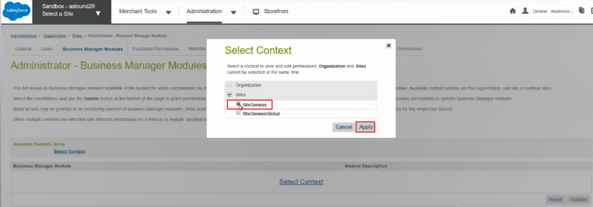
  - Go to Site Preference part of Next Page
  - Check box on line that reads VertexInc
  - Click Update button at bottom right of page

Vertex Connection Configuration
Connection to Vertex From Logging in

  - Click on Merchant Tools on top left hand corner of header
  - Click on Site Preferences link on bottom right hand corner of Merchant Tools Page
  - Click on VertexInc link
  - Enable Vertex Services you need in the "Connect to Vertex" block
    - Enable Vertex allows for the Connector to send Request and receives Responses. If this is unchecks there will not be a connection to Vertex.
    - Enable Invoice Request allows for invoice XML Request to be sent to vertex and the appropriate Vertex XML Responses to be sent back to the connector. This will allow for you to send the needed information for Vertex to make the most accurate Tax Calculation and send that response back to the connector for invoices.
    - Enable VAT Calculation allows to include VAT in the cost of the goods sold, and added to the sales price to the customer.
    - Delivery Terms helps Vertex determine the correct taxing jurisdictions in cross-border transactions ( can be added or changed in Business Manager - Merchant Tools - Site Preferences - Custom Preferences - Vertex).
    - Enable Address Cleansing allows for Address Cleansing to be on and for any Quotation or Invoice that is sent to Vertex to have the most accurate addresses for Vertex to associate it with a Tax Area ID and have the most accurate Tax Response sent back to the customer.
    - Vertex Dashboard link ( can be added or changed in Business Manager - Merchant Tools - Site Preferences - Custom Preferences - Vertex)
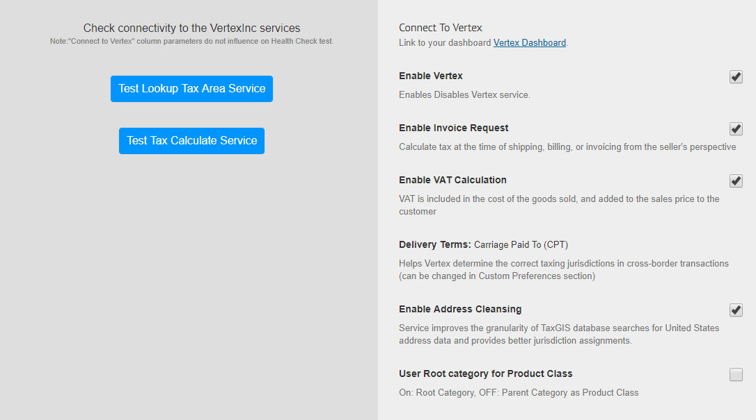

  - Enter API Lookup Tax Area URL and API Tax Calculation Endpoint URL in the input field and fill Credentials block (this urls and credentials are to be provided by Vertex)

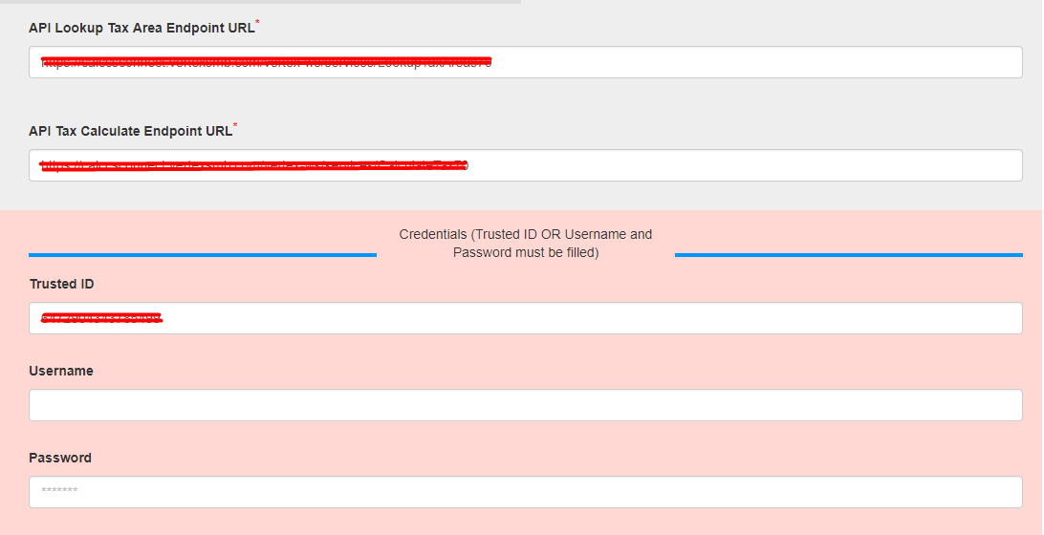

  - Fill Physical Origin block with your information. This will be the Physical Origin that in passed in the Tax Area Look up, Quotation Request and Invoice Requests XML’s to Vertex.

  - Information in Company Field below will be used and passed as Company Code in the Tax Area Look up, Quotation Requests and Invoice Request XML’s to Vertex.
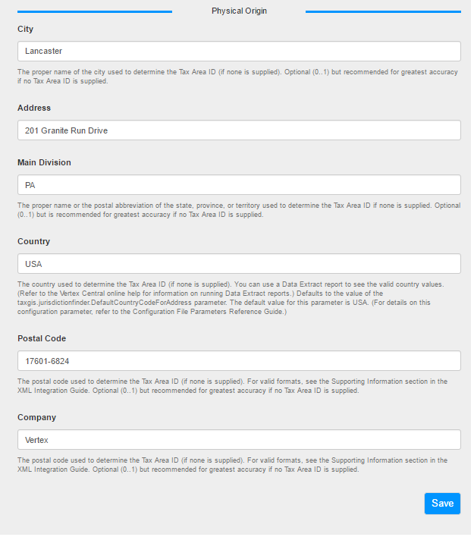
  - If VAT Calculation is enabled, then fill Tax Registration Number and ISO Country Code.
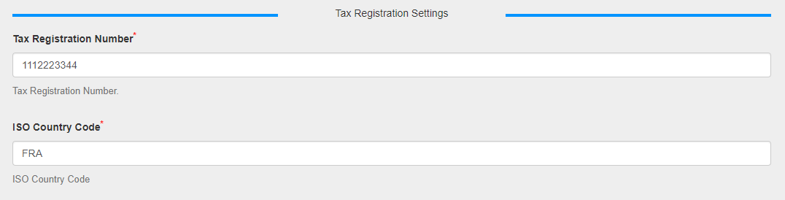
  - Click “Save” to save the preferences.

Check Lookup Tax Area and Tax Calculation services

  - Make sure connection from Connector to Vertex is fine and making sure they have the ability to Lookup Tax Areas and Calculate Taxes correctly.
    - Click on Merchant Tools on top left-hand corner of header
    - Click on Site Preferences link on bottom right hand corner of Merchant Tools Page
    - Click on VertexInc link
    - Click on Test Lookup Tax Area Service and Test Tax Calculation Service
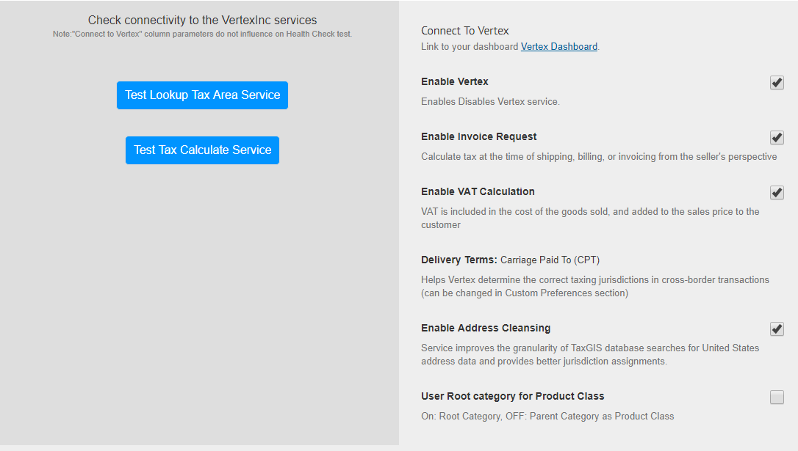
    - If Preferences are correct and Services work, you will see a success message

    - If the preferences or Services are offline you will receive error message and email notification will be sent out to email addresses on the Email Notification Job Configuration
    - See below on how to set up the Email Notification Job Configuration

  - Email Notification Job Configuration-This is important to establish who will be notified if the Run Health Check button /job is run and if there is an issue.
    - Click on Administration on top left-hand corner of header
    - Click on Operations
    - Click on Job Schedules
    - Click on Vertex Health test Link
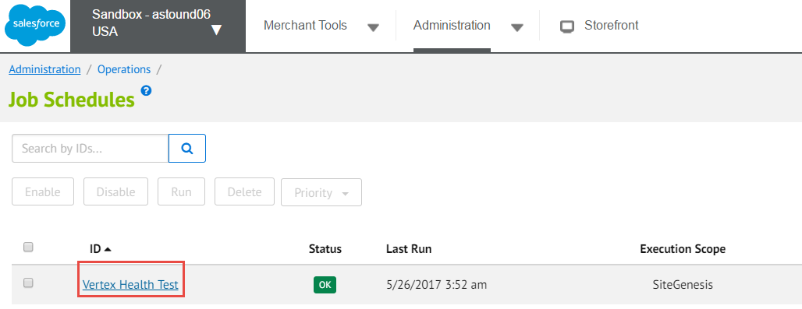

    - Click on Notification Tab towards the Top Middle of the Vertex Health Test Page

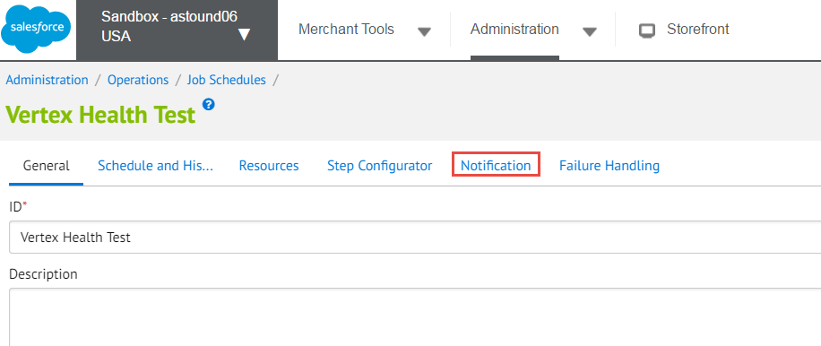
    - Make sure that
      - Enabled box is checked
      - Error box is checked under Threshold
      - Fill out From and To Input fields
        - To field will be a list of all addresses who will receive a failure message if the Health Test is Run and Fails
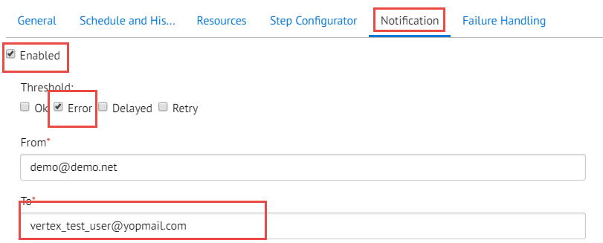

Enabling communications Logs

You must enable communications from the Tax Area Look Up and Tax Calculation calls and the log’s to be able to view the XML’s in the Log files. This is important in assisting in Troubleshooting if you believe there is an issue about Tax Calculation on your site.

To enable the communication logs do the following:

    - Admin->Operations->Services
    - Click on the vertex.Calculate Tax link
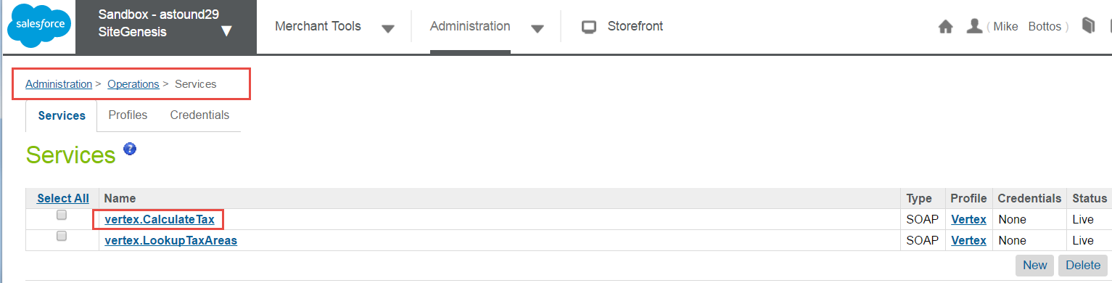
    - Check the box titles “Communication Log Enabled”
    - Click the Apply Button
    - Click on the Back to List Button
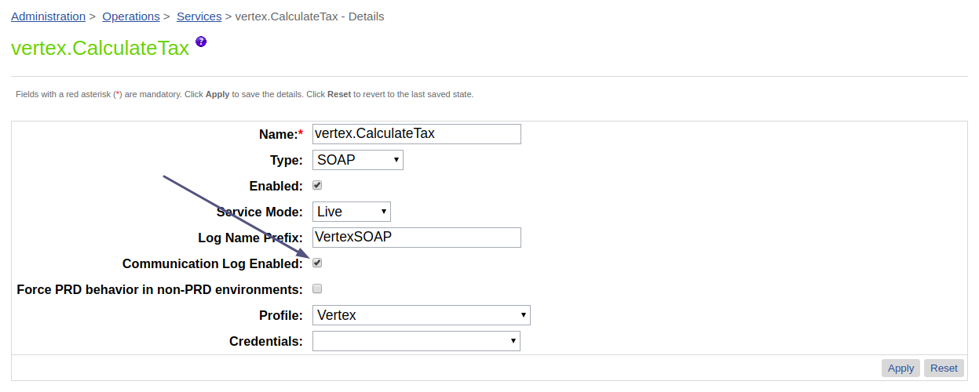
    - Follow the same steps for the vertex.LookupTaxAreas link
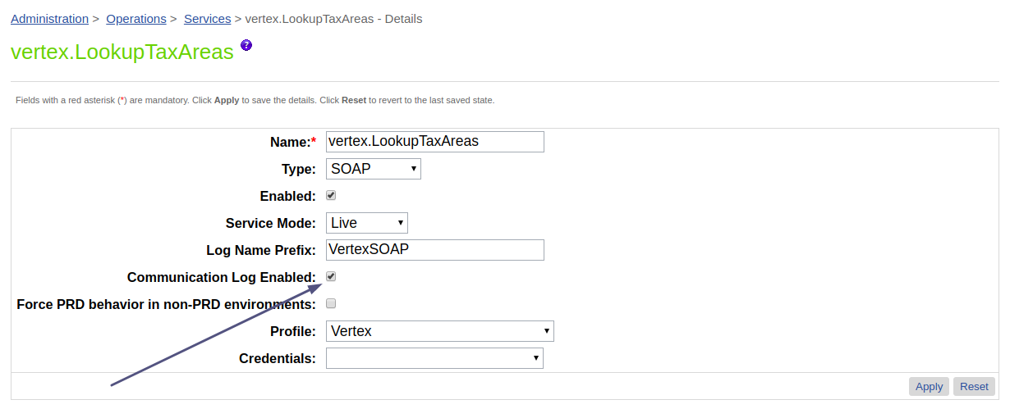
After enabling logs will be written in the file: service-VertexSOAP-<instance_name>-appserver-<current_date>.log

5. Edit Custom Log Settings

    - Go to Administration->Operations->Custom Log Settings
    - Make sure the preferences match what is shown below and click the Save button
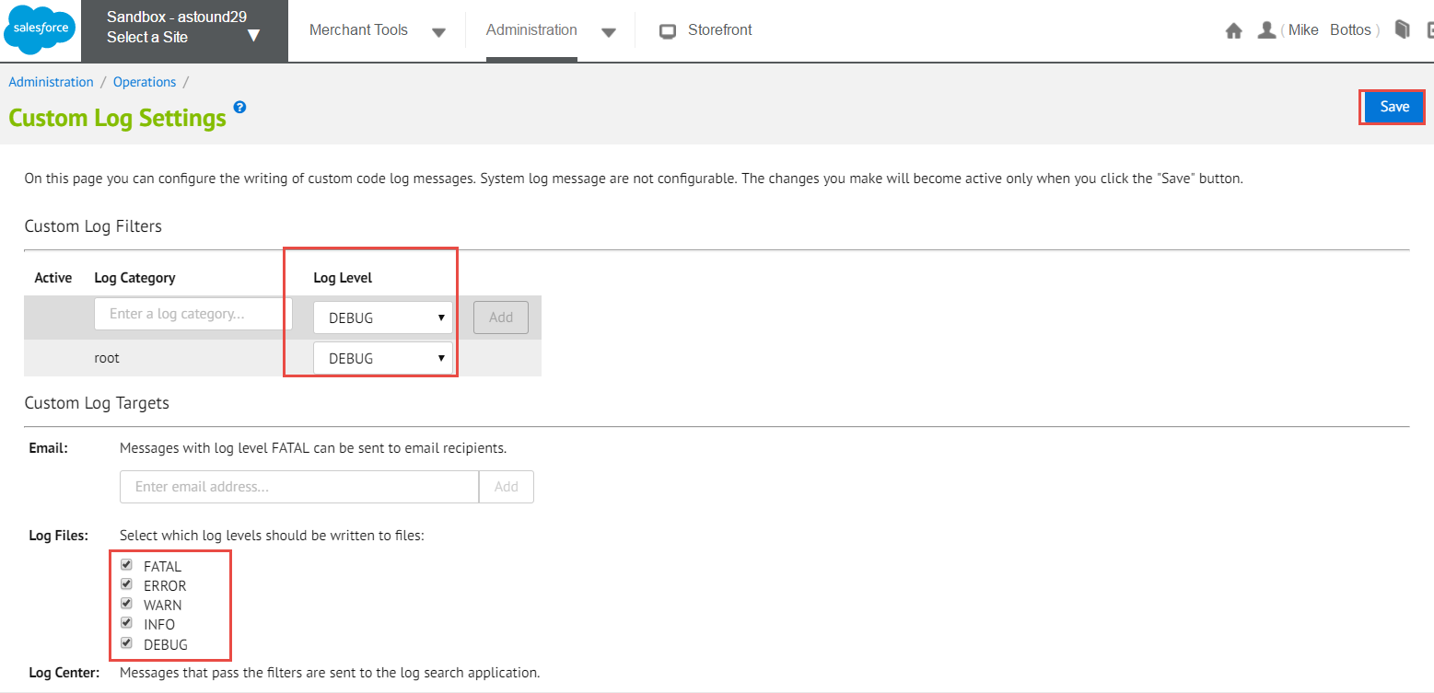

    - You have now enabled all Tax Area Look Up and Tax Calculation calls to have the XML’s available in the Log Files.
    - To access the log files go to
- Administration->Site Development->Development Setup-> Log Files
- Look for files logs named 'customInfo-<instance_name>-appserver-<current_date>.log' or 'info-<instance_name>-appserver-<current_date>.log'
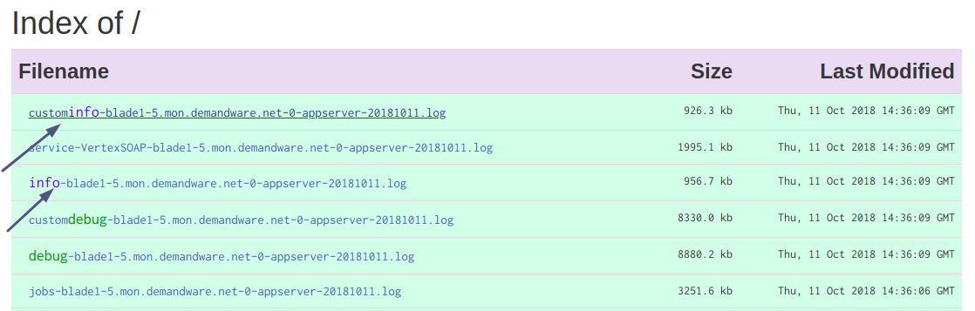
- Click on the log file link
- Search for the XML log file you need

Example of a Request and Response

Request:

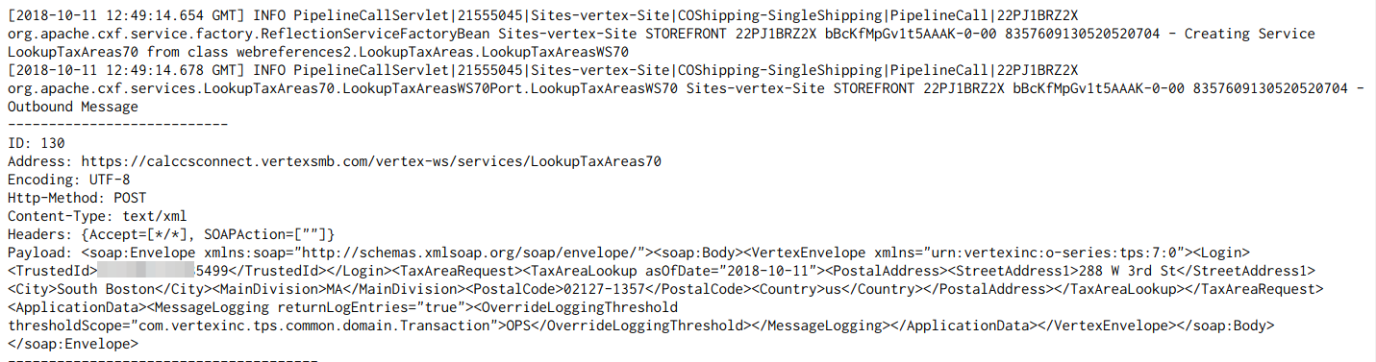

Response:

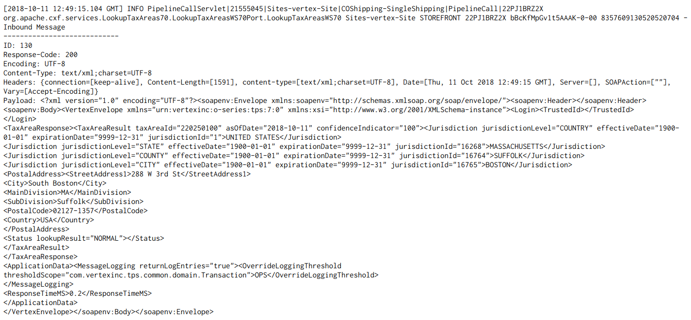

Chapter 2. Custom Code Changes

Controllers

COShipping.js

Open <YOUR_CONTROLLERS_CARTRIDGE>/cartridge/controllers/COShipping.js
1. Insert on line 23:

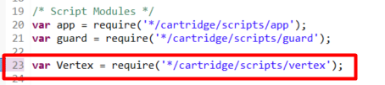
var Vertex = require('int_vertex/cartridge/scripts/vertex');

2. Near line 81 insert:
delete session.privacy.VertexAddressSuggestionsError

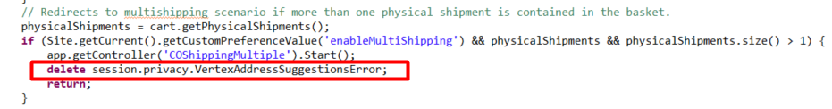
2. Near line 89 find:

app.getForm('singleshipping.shippingAddress.addressFields').copyFrom(cart.getDefaultShipment().getShippingAddress());
app.getForm('singleshipping.shippingAddress.addressFields.states').copyFrom(cart.getDefaultShipment().getShippingAddress());
app.getForm('singleshipping.shippingAddress').copyFrom(cart.getDefaultShipment());

3. Replace selected code with:

if(!Vertex.isEnabled) {
app.getForm('singleshipping.shippingAddress.addressFields').copyFrom(cart.getDefaultShipment().getShippingAddress());
app.getForm('singleshipping.shippingAddress.addressFields.states').copyFrom(cart.getDefaultShipment().getShippingAddress());
app.getForm('singleshipping.shippingAddress').copyFrom(cart.getDefaultShipment());
}

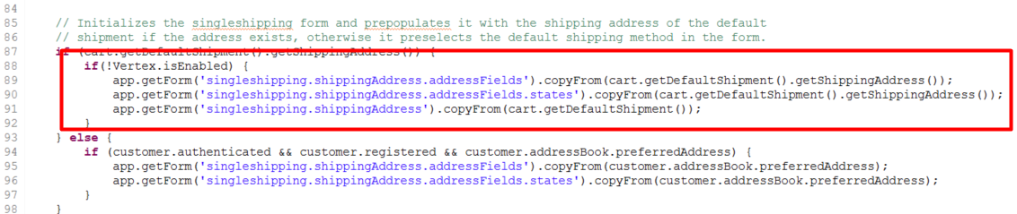

4. Find function handleShippingSettings(cart) and insert one line into Transaction.wrap:
shippingAddress.custom.taxnumber = session.forms.singleshipping.shippingAddress.addressFields.taxnumber.value;
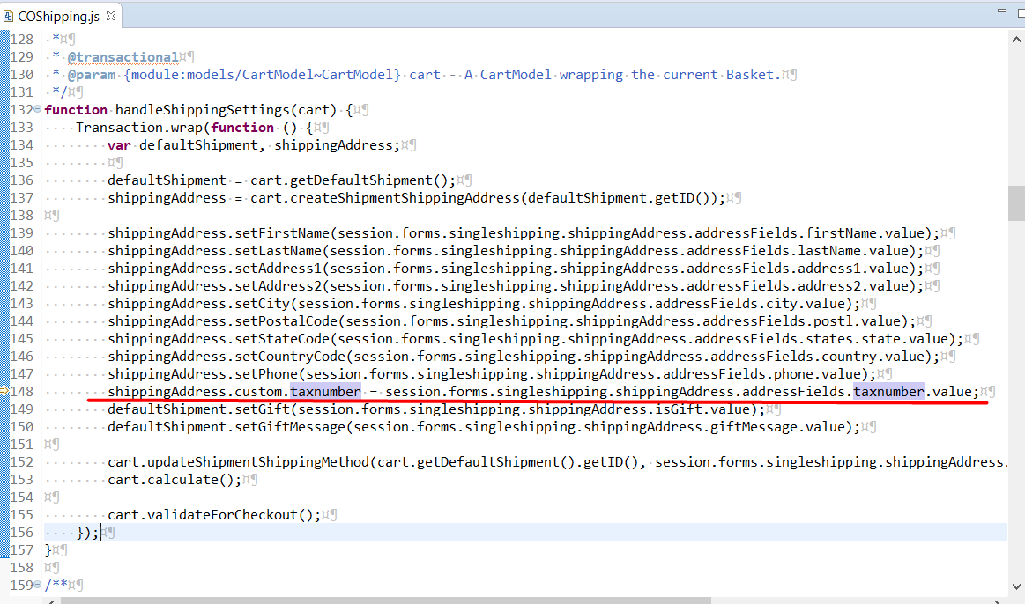

5. Near line 232 find code: handleShippingSettings(cart) and insert above:
var result = Vertex.LookupTaxAreas(singleShippingForm, cart.object);
if(!result) {
start();
return;
}

delete session.privacy.VertexAddressSuggestionsError;
delete session.privacy.VertexAddressSuggestions;
delete session.privacy.VertexAddressSelected;

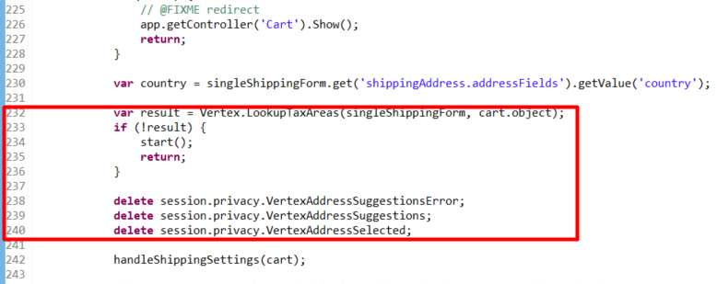
6. After call handleShippingSettings(cart) change if condition for authenticated customer from
if (customer.authenticated && session.forms.singleshipping.shippingAddress.addToAddressBook.value) {
app.getModel('Profile').get(customer.profile).addAddressToAddressBook(cart.getDefaultShipment().getShippingAddress()); }
to
if (customer.authenticated && session.forms.singleshipping.shippingAddress.addToAddressBook.value) {
var newAddress = app.getModel('Profile').get(customer.profile).addAddressToAddressBook(cart.getDefaultShipment().getShippingAddress());
var taxnumber = singleShippingForm.get('shippingAddress.addressFields').getValue('taxnumber');
Transaction.wrap(function() {
newAddress.custom.taxnumber = taxnumber;
});
}
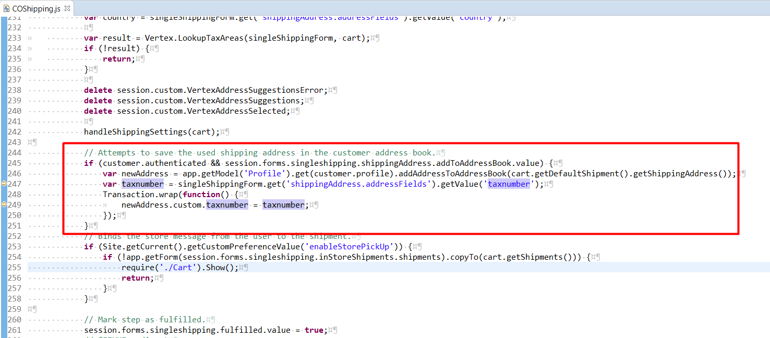

COPlaceOrder.js

Open <YOUR_CONTROLLERS_CARTRIDGE>/cartridge/controllers/COPlaceOrder.js
1. Insert: var Vertex = require('*/cartridge/scripts/vertex'); on line 27

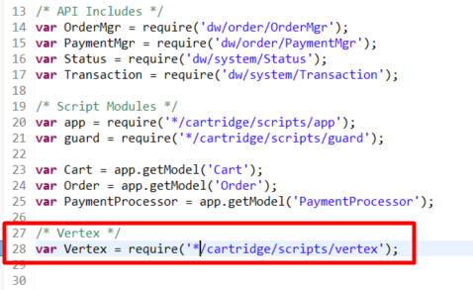
2. Near line 75 find: return {}; Insert above:
Vertex.CalculateTax('Invoice', order);

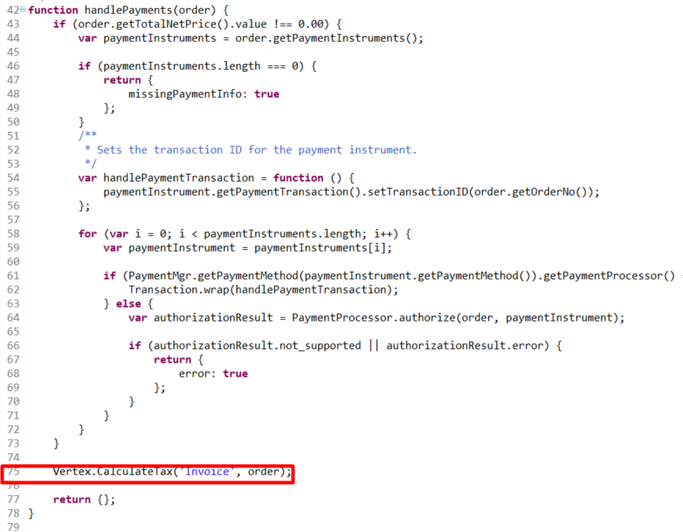

Address.js

Open <YOUR_CONTROLLERS_CARTRIDGE>/cartridge/controllers/Address.js
1. modify addressForm.handleAction function create method as follows
create: function () {

var createAddress = Address.create(session.forms.profile.address);
if (!session.forms.profile.address.valid || !createAddress) {
response.redirect(URLUtils.https('Address-Add'));
success = false;
}

Transaction.wrap(function () {
createAddress.object.custom.taxnumber = request.httpParameterMap.dwfrm_profile_address_taxnumber.value;
});

success = true;
}
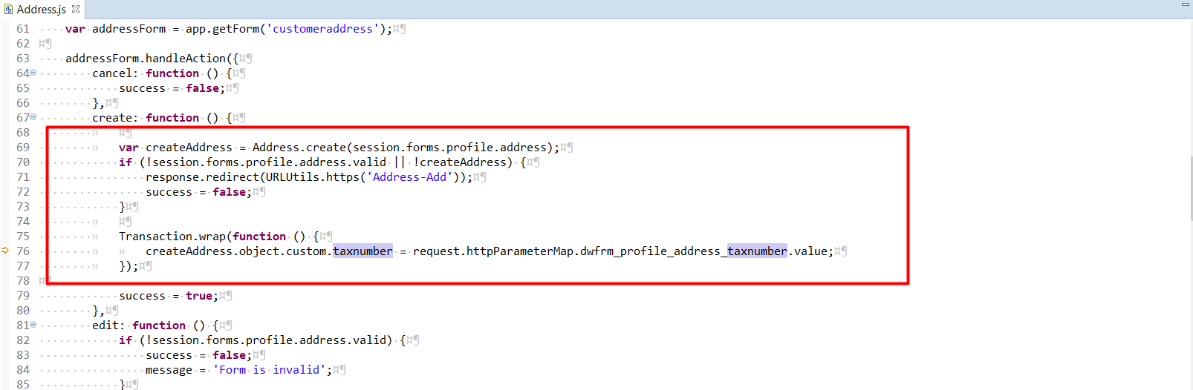

2. modify addressForm.handleAction function edit method as follows:
edit: function () {
if (!session.forms.profile.address.valid) {
success = false;
message = 'Form is invalid';
}
try {
var updatedAddress = Address.update(request.httpParameterMap.addressid.value, session.forms.profile.address);
var taxnumber = session.forms.profile.address.taxnumber.value;
Transaction.wrap(function() {
updatedAddress.object.custom.taxnumber = taxnumber;
});
success = true;
} catch (e) {
success = false;
message = e.message;
}
},
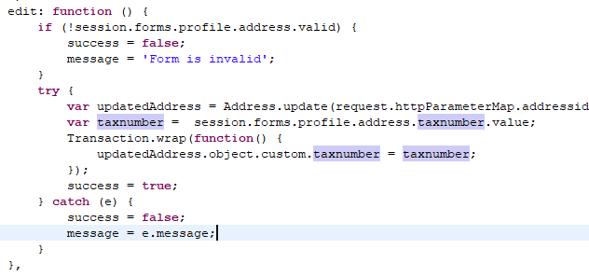
3. Find function edit() and add line:
app.getForm(profileForm.address).setValue('taxnumber', address.custom.taxnumber);
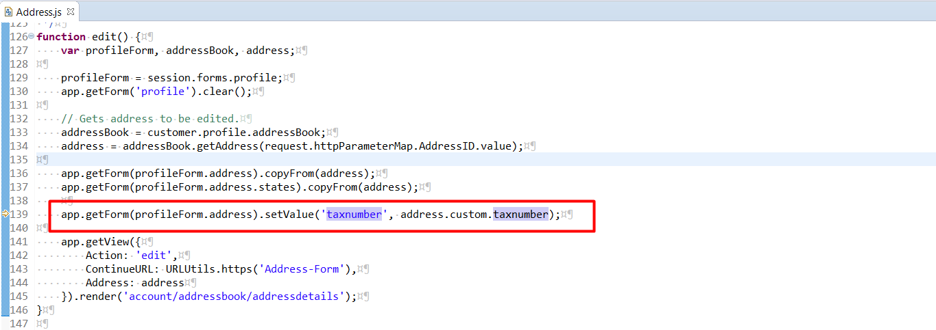

COShippingMultiple.js

Open YOUR_CONTROLLERS_CARTRIDGE>/cartridge/controllers/COShippingMultiple.js
1. find function editAddresses() and add code at the beginning.
delete session.privacy.VertexAddressSuggestions;
delete session.privacy.VertexAddressSuggestionsError;
and
session.privacy.VertexAddressSelected = false;
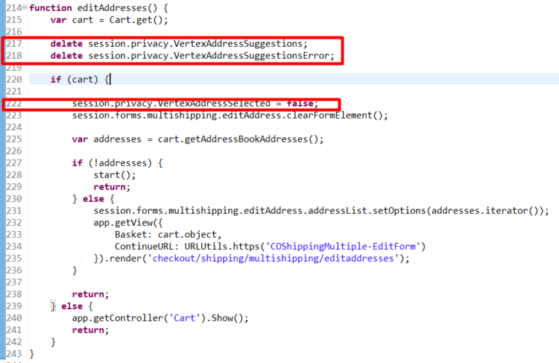
2. modify code in addEditAddress function near line 320 as follows:
if (addToCustomerAddressBook && addToCustomerAddressBook === true) {
if (referenceAddress) {
// Gets address from address book.
if (referenceAddress.ID) {
customerAddress = customer.addressBook.getAddress(referenceAddress.ID);
}
} else {
customerAddress = Transaction.wrap(function () {
return app.getModel('Profile').get(customer.profile).addAddressToAddressBook(newAddress);
});
newAddress.ID = customerAddress.ID;
newAddress.referenceAddressUUID = customerAddress.getUUID();
Transaction.wrap(function () {
customerAddress.custom.taxnumber = session.forms.multishipping.editAddress.addressFields.taxnumber.value;
});
}

if (customerAddress) {
var helperAddress = new TransientAddress();
helperAddress.copyFrom(newAddress);
helperAddress.custom = { taxnumber:newAddress.taxnumber };
Transaction.wrap(function () {
helperAddress.copyTo(customerAddress);
});
}
}
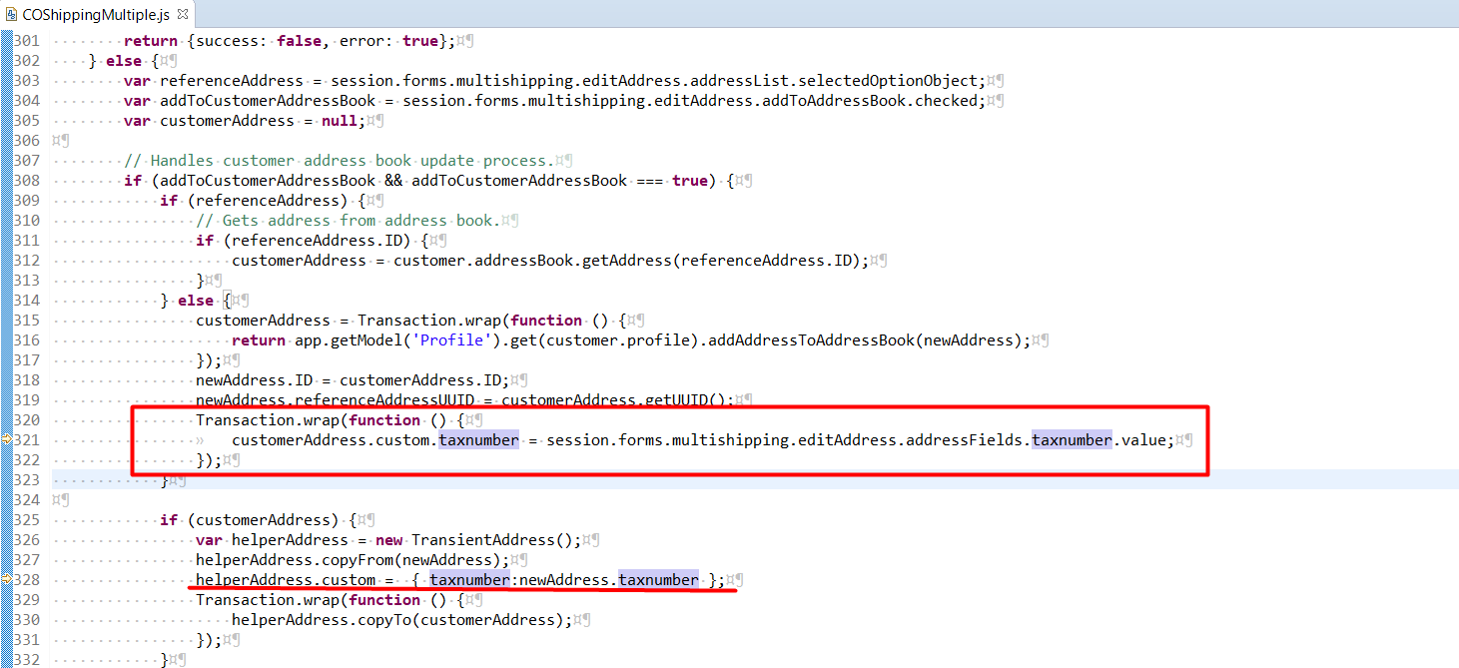

COBilling.js
Open YOUR_CONTROLLERS_CARTRIDGE>/cartridge/controllers/COBilling.js.
1. Find function initAddressForm(cart) update it with one line:
app.getForm('billing').object.billingAddress.addressFields.taxnumber.value = app.getForm('singleshipping').get('shippingAddress.addressFields').getValue('taxnumber');

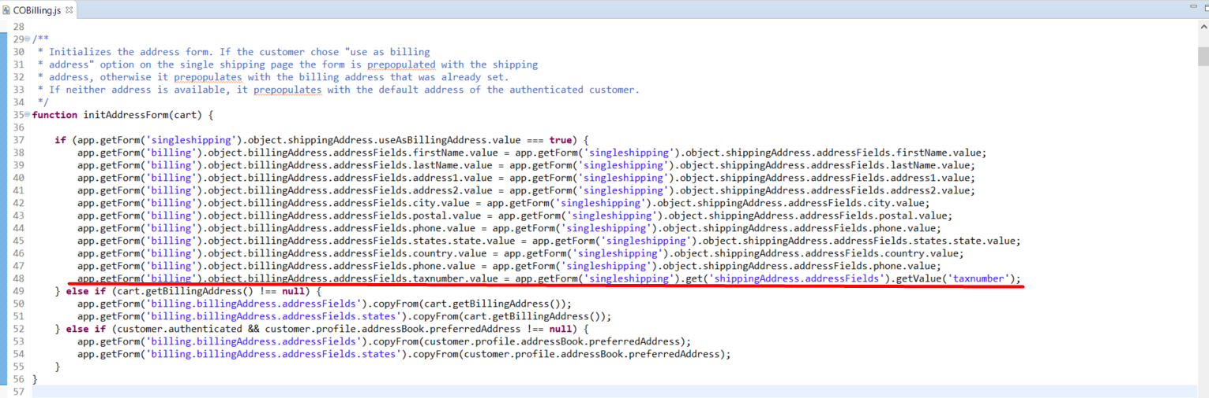

2. Find function billing() and update save method with following code:
if (!empty(cart.object.billingAddress)) {
Transaction.wrap(function(){
cart.object.billingAddress.custom.taxnumber = session.forms.billing.billingAddress.addressFields.taxnumber.value;
});
}

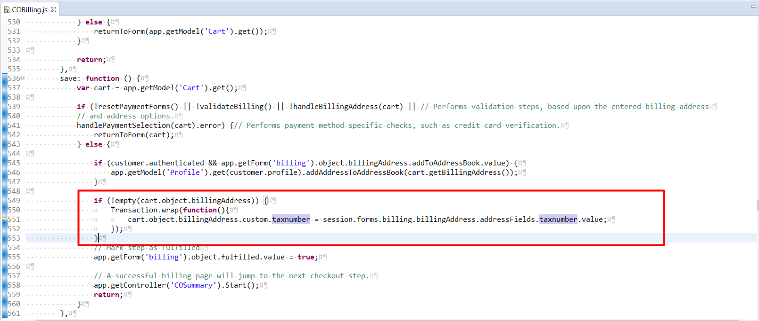

Form definitions

shippingaddress.xml
1. Open <YOUR_STOREFRONT_CARTRIDGE>/cartridge/forms/default/shippingaddress.xml

Add code near line 25 as follows :

<field formid="taxnumber" label="resource.taxnumber" type="string" mandatory="false" min-length="2" max-length="10" binding="taxnumber"
missing-error="resource.errortaxnumber"/>

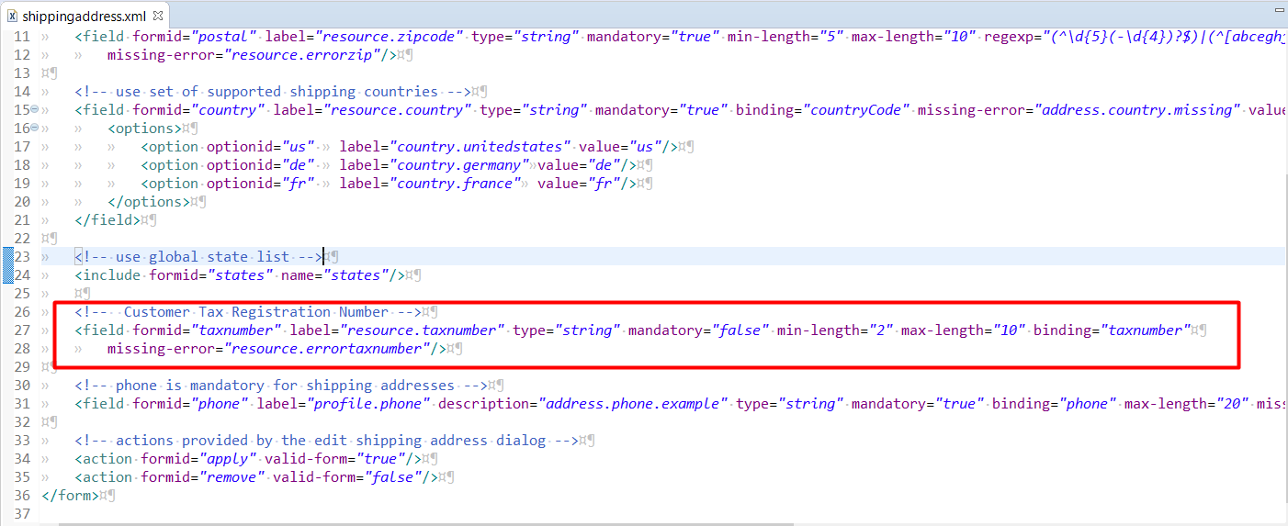

billing.xml
2. Open <YOUR_STOREFRONT_CARTRIDGE>/cartridge/forms/default/billing.xml
Add code near line 25 as follows:
<field formid="taxnumber" label="resource.taxnumber" type="string" mandatory="false" min-length="2" max-length="20" binding="taxnumber"
missing-error="resource.errortaxnumber"/>

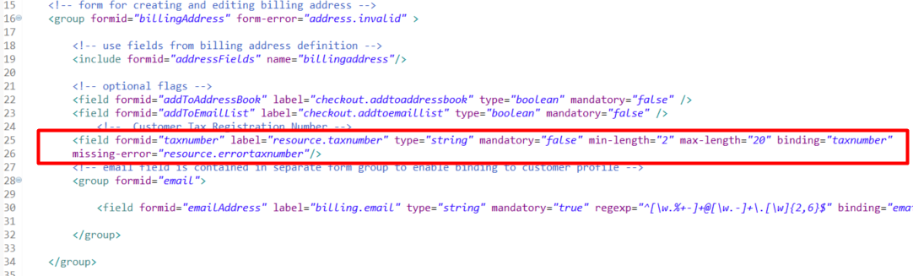

billingaddress.xml
3. Open <YOUR_STOREFRONT_CARTRIDGE>/cartridge/forms/default/billingaddress.xml

Add code near line 30 as follows:

<field formid="taxnumber" label="resource.taxnumber" type="string" mandatory="false" min-length="2" max-length="10" binding="taxnumber"
missing-error="resource.errortaxnumber"/>

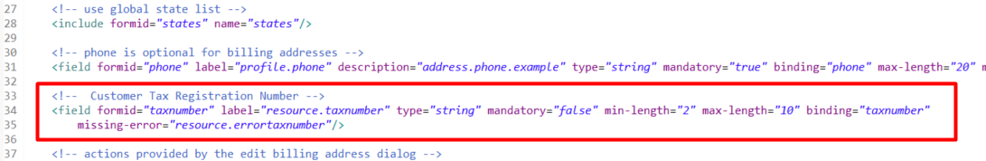

customeraddress.xml
4. Open <YOUR_STOREFRONT_CARTRIDGE>/cartridge/forms/default/customeraddress.xml

Add code near line 33 as follows:

<field formid="taxnumber" label="resource.taxnumber" type="string" mandatory="false" binding="taxnumber" max-length="10"
missing-error="customeraddress.taxnumber.missing-error"/>

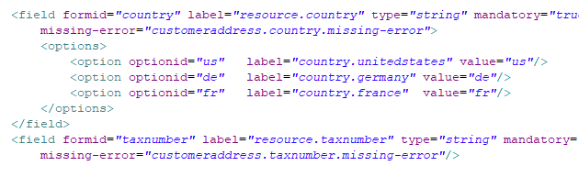

Models

CartModel.js
1. Open <YOUR_CONTROLLERS_CARTRIDGE>/cartridge/scripts/models/CartModel.js
add code near line 1348 as follows:

if ('taxnumber' in addressToAdd.custom) {
if (addressToAdd.custom.taxnumber != 'undefined') {
address.taxnumber = addressToAdd.custom.taxnumber;
}
}

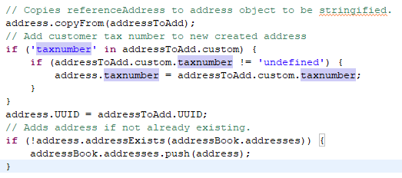

ProfileModel.js
2. Open <YOUR_CONTROLLERS_CARTRIDGE>/cartridge/scripts/models/ProfileModel.js

Add code near line 151 as follows:

address.custom.taxnumber = addressToAdd.taxnumber;

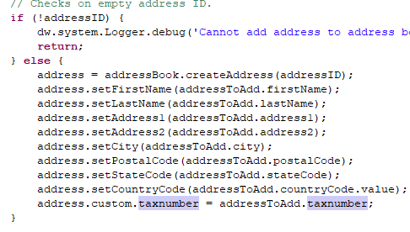

Scripts

CartUtil.ds
1. Open <YOUR_STOREFRONT_CARTRIDGE>/cartridge/scripts/cart/CartUtil.ds

add code near line 35 as follows:

taxnumber: addy.custom.taxnumber

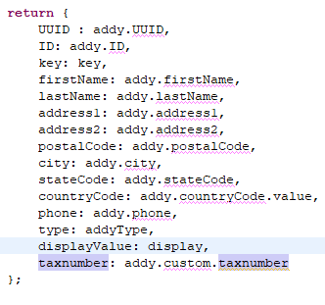

MergeQuantities.js
2. Open <YOUR_STOREFRONT_CARTRIDGE>/cartridge/scripts/checkout/multishipping/MergeQuantities.js

add code near line 122 as follows:

orderAddress.custom.taxnumber = address.taxnumber;

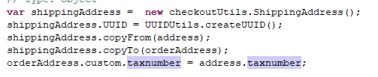

calculate.js
3. Open <YOUR_STOREFRONT_CARTRIDGE>/cartridge/scripts/cart/calculate.js
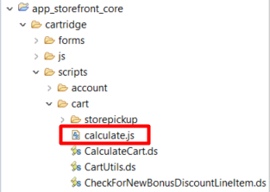

Insert: var Vertex = require('*/cartridge/scripts/vertex'); on line 19

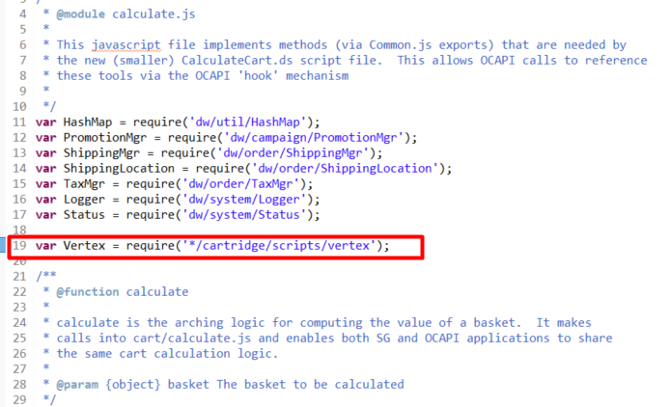
On line 86 replace code: calculateTax(basket); by:
if(Vertex.isEnabled()) {
Vertex.CalculateTax('Quotation', basket);
} else {
calculateTax(basket);
}

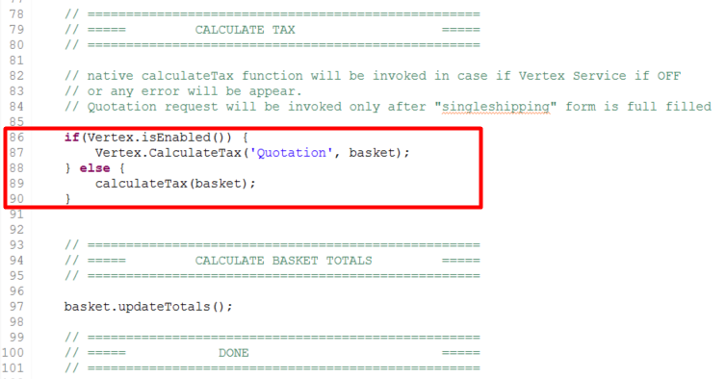

Resource.ds
4. Open <YOUR_STOREFRONT_CARTRIDGE>/cartridge/scripts/util/Resource.ds find ResourceHelper.getUrls function and update with one line:
getSuggest: URLUtils.url('VertexEndpoint-GetSuggest').toString()

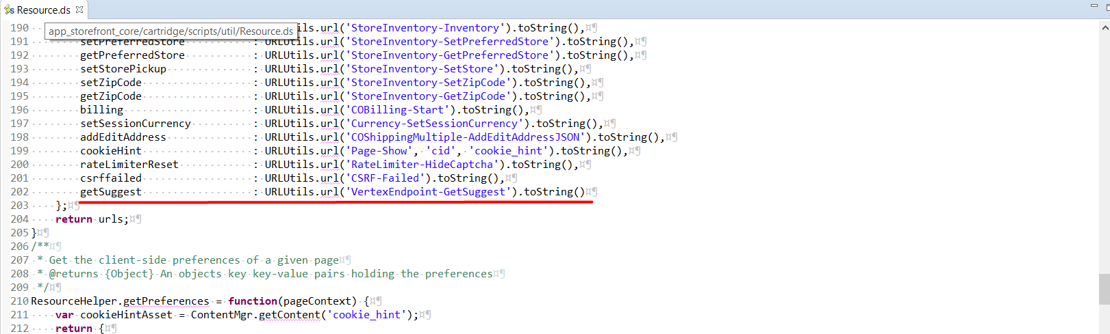

Templates

1. Open <YOUR_STOREFRONT_CARTRIDGE>/cartridge/templates/default/account/addressbook/miniaddress_localized.isml add code near line 41 as follows:
<iscomment> Tax Registration Number</iscomment>
<isif condition="${pdict.p_address.custom.taxnumber}">
<br/>${Resource.msg('account.addressbook.miniaddress.tax_number','account',null)}
<isprint value="${pdict.p_address.custom.taxnumber}"/>
</isif>
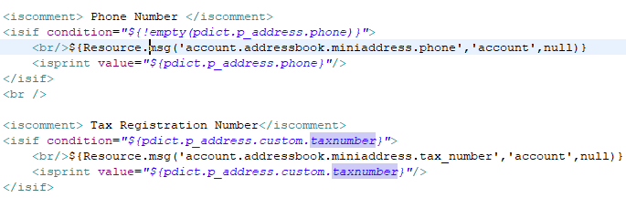

2. Open <YOUR_STOREFRONT_CARTRIDGE>/cartridge/templates/default/checkout/components/minicheckout_address.isml add code near line 17 as follows:

<isif condition="${pdict.p_address.custom.taxnumber && (pdict.p_address.custom.taxnumber != 'undefined')}">
<div><isprint value="${pdict.p_address.custom.taxnumber}"/></div>
</isif>
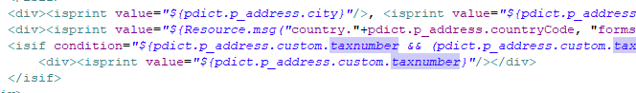

3. Open <YOUR_STOREFRONT_CARTRIDGE>/cartridge/templates/default/checkout/shipping/shippingaddressdetails.isml add code near line 47 as follows:

<div class="formfield clearfix">
<isinputfield formfield="${pdict.CurrentForms.shippingaddress.taxnumber}" type="input"/>
</div>

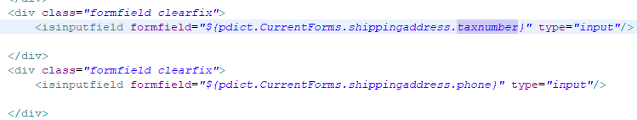

4. Open <YOUR_STOREFRONT_CARTRIDGE>/cartridge/templates/default/checkout/shipping/singleshipping.isml add one line as follows:

<isinclude template="checkout/vertex/suggestions"/>
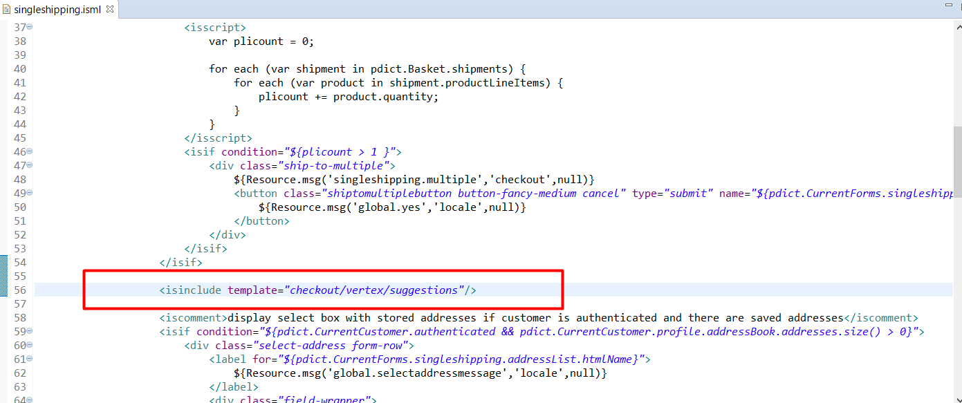

JS
1. Open <YOUR_STOREFRONT_CARTRIDGE>/cartridge/js/pages/checkout/shipping.js find export.init function and add code snippet:

var $form = $('.checkout-shipping');

if ($form.find('select[name$="_country"]').val() != 'us') {
$form.find('select[name$="_state"]').parents('.form-row').hide();
}

$form.on('change','select[name$="_country"]', function(e){
if (e.target.value != 'us') {
$form.find('select[name$="_state"]').parents('.form-row').hide();
} else {
$form.find('select[name$="_state"]').parents('.form-row').show();
}
});

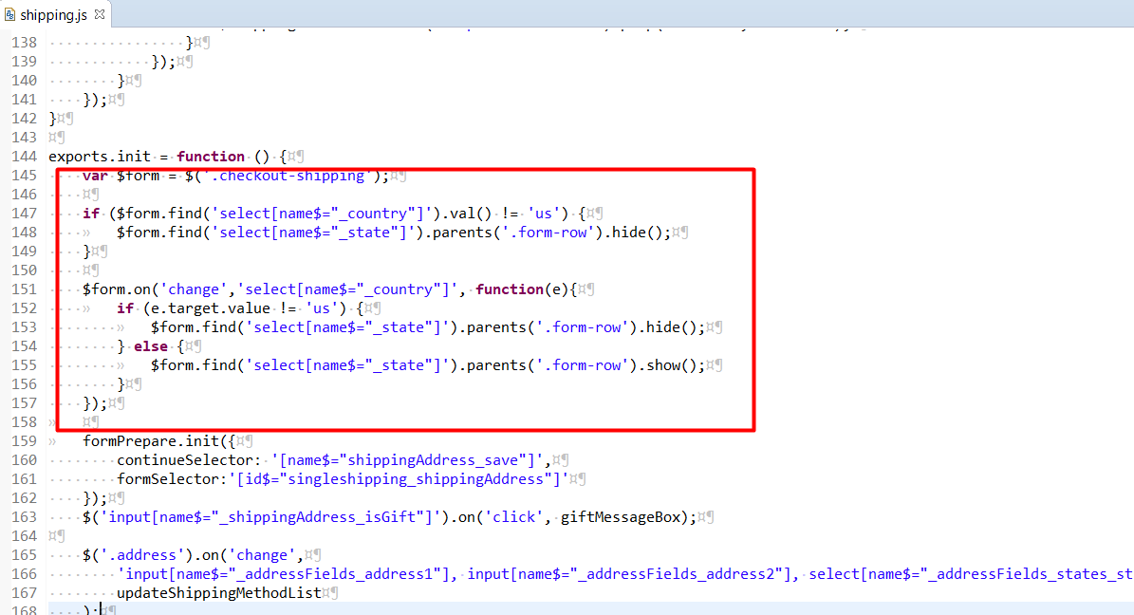

2. Open <YOUR_STOREFRONT_CARTRIDGE>/cartridge/js/pages/checkout/billing.js find export.init function and add code snippet:

$checkoutForm.on('change','select[name$="_country"]', function(e){
if (e.target.value != 'us') {
$checkoutForm.find('select[name$="_state"]').parents('.form-row').hide();
} else {
$checkoutForm.find('select[name$="_state"]').parents('.form-row').show();
}
});

formPrepare.init({
formSelector: 'form[id$="billing"]',
continueSelector: '[name$="billing_save"]'
});

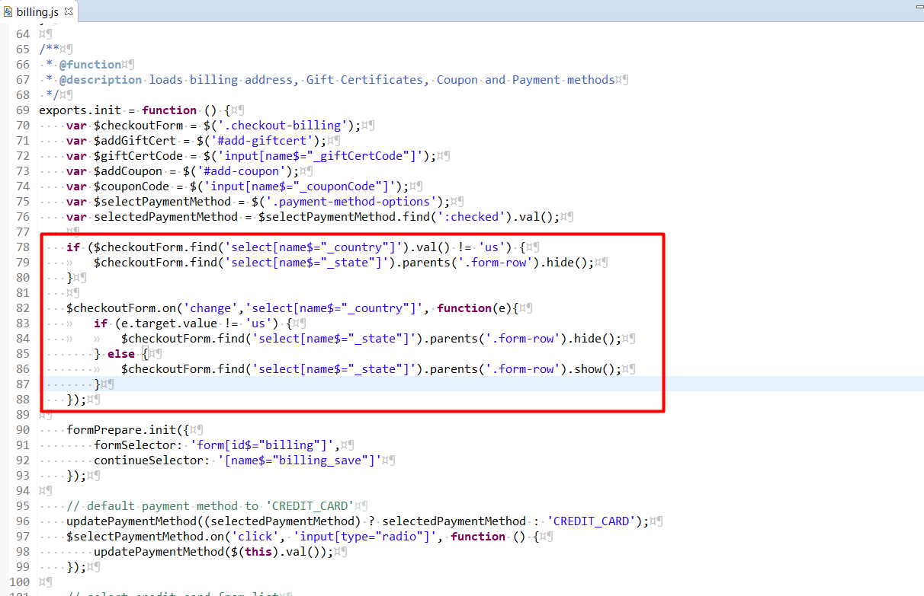

3. Open <YOUR_STOREFRONT_CARTRIDGE>/cartridge/js/pages/account.js find initializeAddressForm function and add code snippet:
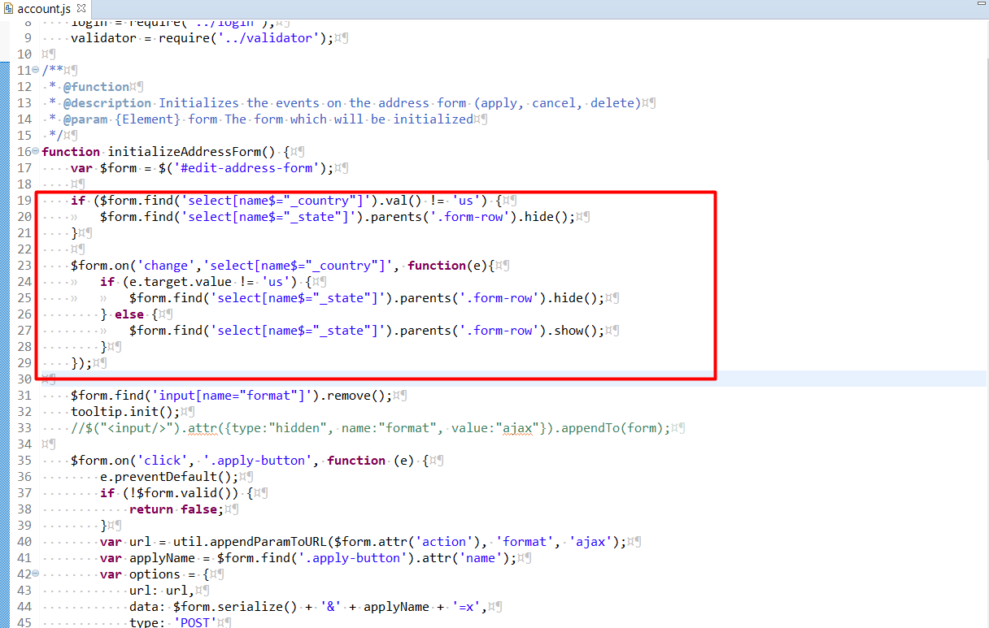

4. Open <YOUR_STOREFRONT_CARTRIDGE>/cartridge/js/pages/checkout/multiship.js find addEditAddressfunction and add code snippet:

if ($addressForm.find('select[name$="_country"]').val() != 'us') {
$addressForm.find('select[name$="_state"]').parents('.form-row').hide();
}

$addressForm.on('change', function(e) {
$addressForm.data('ischanged' , true);
$addressForm.data('isskip', false);
});

$(document).on('change','.multisuggestion [name=dwfrm_multishipping_editAddress]', function(e) {
var selected = $(e.target).children(':selected').first();
var selectedAddress = $(selected).data('address');
if (!selectedAddress) { return; }
util.fillAddressFields(selectedAddress, $addressForm);
// re-validate the form
$addressForm.validate().form();
$addressForm.data('ischanged' , false);
});

$addressForm.on('change','select[name$="_country"]', function(e){
if (e.target.value != 'us') {
$addressForm.find('select[name$="_state"]').parents('.form-row').hide();
} else {
$addressForm.find('select[name$="_state"]').parents('.form-row').show();
}
});

and update function onchange handler for $addressDropdown:

$addressForm.data('ischanged', true);
$addressForm.data('isskip', false);

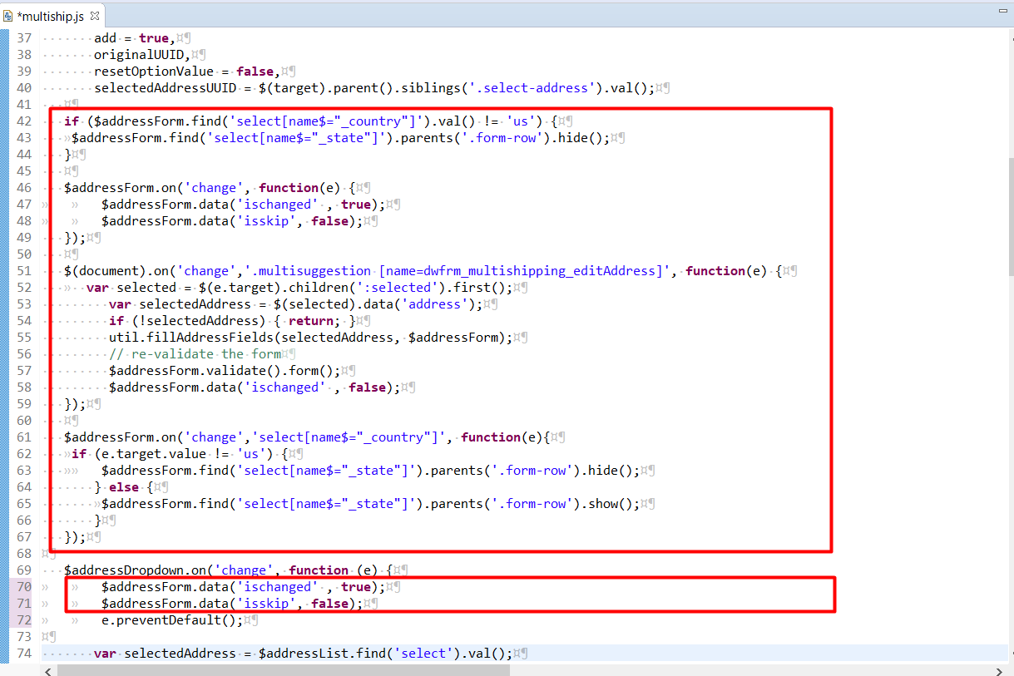

Find function onsubmit handler for $addressForm and add before handler following line:
$addressForm.attr('data-isskip', false);

Update onsubmit handler for $addressForm with following code snippet:
if(!$addressForm.data('isskip') && ($addressForm.find('select[name$="_country"]').val() == 'us')) {
if ($addressForm.data('ischanged')) {
$.ajax({
type: 'POST',
url: window.Urls.getSuggest +'?multishipping=true',
data: $addressForm.serialize()
}).done(function (response) {
if (!response.text) {
$addressForm.data('ischanged', !response.success);
$addressForm.data('isskip', response.success);
$addressForm.submit();
} else {
$addressForm.data('ischanged', false);
$addressForm.data('isskip', true);
$('.multisuggestion').remove();
$('#edit-address-form').before(response.text);
}
});
return false;
}
};

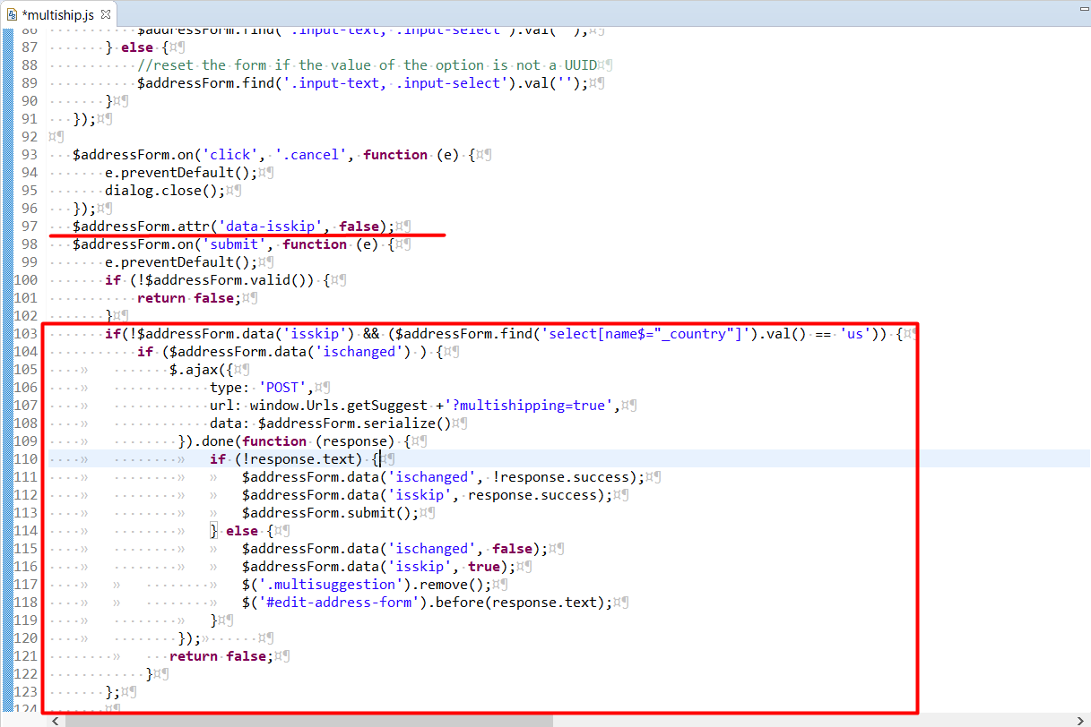

Resources

Open <YOUR_STOREFRONT_CARTRIDGE>/cartridge/templates/resources/forms.properties
add code near line 119 as follows:
resource.taxnumber=Tax Registration Number
resource.errortaxnumber=Sorry, the tax number is missing
